STRUCTURED QUESTIONS (50 MARKS)
Instruction: Answer ALL QUESTIONS on the space provided.
- Define the term of Database Management System (DBMS).
(2 marks)
Software system that enables users to define, create, and maintain the database and which provides controlled access to this database.

- Briefly explain the elements of data that is logically related in database.
(3 Marks)
Entity – a distinct object in the organization
Attribute – a property that describe some aspect of entity
Relationship – an association between entities

3. Explain the differences between Logical Data Independence and Physical Data Independence for the database architecture.
(5 marks)
- Logical Data Independence [1 m]
- Refers to immunity of external schemas to changes in conceptual schema. [1/2 m]
- Conceptual schema changes (e.g. addition/removal of entities). [1/2 m]
- Should not require changes to external schema or rewrites of application programs. [1/2 m]
- Physical Data Independence [1 m]
  - Refers to immunity of conceptual schema to changes in the internal schema. [1/2 m]
  - Internal schema changes (e.g. using different file organizations, storage
    - structures/devices). [1/2 m]
  - Should not require change to conceptual or external schemas. [1/2 m]

- Explain the THREE (3) types of update anomalies that might occur in a table with redundant data.
(6 marks)
Insertion anomaly
-a new row cannot be inserted unless all primary key values are supplied
Deletion anomaly
-deleting a row results in losing important information not stored elsewhere
Modification anomaly
A simple update must be applied to multiple rows

- Explain the main goal of normalization process.
(2 marks)

Main goal in developing logical data model for relational database systems is to create an accurate representation of the data, its relationship and constraints

- Describe the concept of functional dependency in relation.
(2 marks)
Describe relationship between attributes in a relation. If A and B are attributes of relation R, B is functionally dependent on A (denoted A B), if each value of A in R is associated with exactly one value of B in R.

- Read the following case study:
A virtual art gallery is managing its collection of digital artworks. The gallery wants to keep track of various details about the artworks and the artists who create them. Each artwork can belong to multiple categories and each category can contain multiple artworks. Each artist can create multiple artworks and an artwork can be created by multiple artists.
Identify all possible entities involved in the above scenario. For every entity, determine at least THREE (3) attributes and mark the relevant keys. Based on the identified entities, draw an Entity Relationship Diagram (ERD) by showing all the necessary relationships and multiplicity constraints.
(10 Marks)

Answer:
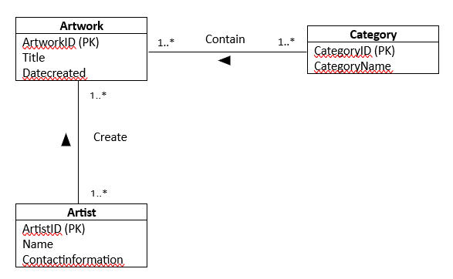

Marks:
- Entities – 3 m
- Attributes – 4 m
- relationship name – 1 m
- multiplicity – 2 m

- Map the following Enhanced Entity Relationship (EER) diagram into Database Relational Model

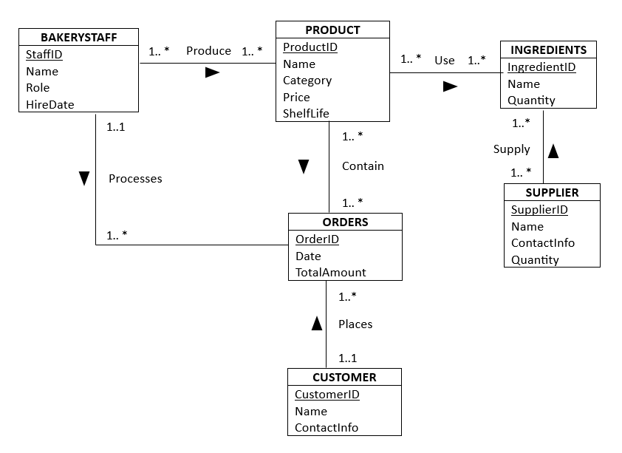

(10 Marks)
Answer:

BAKERYSTAFF (StaffID, Name, Role, HireDate) [0.5m]
PRIMARY KEY StaffID [0.25]

BAKERYSTAFF_PRODUCT (StaffID, ProductID) [0.5]
FOREIGN KEY StaffID REFERENCES BAKERYSTAFF (StaffID) [0.25]
FOREIGN KEY ProductID REFERENCES PRODUCT (ProductID) [0.25]

PRODUCT (ProductID, Name, Category, Price, ShelfLife) [0.5m]
PRIMARY KEY ProductID [0.25]

PRODUCT_INGREDIENTS (ProductID, IngredientID) [0.5m]
FOREIGN KEY ProductID REFERENCES PRODUCT [0.25]
FOREIGN KEY IngredientID REFERRENCES INGREDIENTS [0.25]

INGREDIENTS (IngredientID, Name, Quantity) [0.5m]
PRIMARY KEY IngredientID [0.25]

PRODUCT_ORDERS (ProductID, OrderID) [0.5m]
FOREIGN KEY ProductID REFERENCES PRODUCT [0.25]
FOREIGN KEY OrderID REFERENCES ORDERS [0.25]

ORDERS (OrderID, Date, TotalAmount) [0.5m]
PRIMARY KEY OrderID [0.25]
FOREIGN KEY CustomerID REFERENCES CUSTOMER [0.25]
FOREIGN KEY StaffID REFERENCES STAFF [0.25]

SUPPLIER_INGREDIENTS (SupplierID, IngredientID) [0.5m]
FOREIGN KEY SupplierID REFERENCES SUPPLIER [0.25]
FOREIGN KEY IngredientID REFERENCES INGREDIENTS [0.25]

SUPPLIER (SupplierID, Name, ContactInfo, Quantity) [0.5m]
PRIMARY KEY SupplierID [0.25]

CUSTOMER (CustomerID, Name, ContactInfo) [0.5m]
PRIMARY KEY CustomerID [0.25]

Follow correct formatting – 1m

- Examine the following PRODUCT and SUPPLIER table:
 | Product_No | Product_Name | Supplier_ID | Supplier_Name | Supplier_Add | Type_ID | Type_  Description | Quantity | Price
 | A05 | A4 paper | S01 | BayuSdn. Bhd | AlorSetar | S | Small | 50 | RM 100
 | A03 | Markerpen | S01 | BayuSdn. Bhd | AlorSetar | S | Small | 20 | RM 60
 | A06 | Stapler | S02 | SYK Sdn. Bhd | Jitra | L | Large | 50 | RM 200
A06 |  | Stapler | S03 | Best Sdn. Bhd | Kangar | M | Medium | 40 | RM 250

Given the functional dependencies are as follows:
Product_No, Supplier_ID Quantity, Price
Product_NoProduct_Name
Supplier_IDSupplier_Name, Supplier_Address, Type_ID,Type_Description
Type_IDType_Description

Answer the following questions based on the given table and functional dependencies.
- Which normalization form does the table above in?
(2 marks)
1 NF
- Perform the process of normalization to 3NF.
(8 marks)
INF
PRODUCT_SUPPLIER (ProductNo, SupplierID, Quantity, Price, ProductNAme, SupplierName, SupplierAddress, TypeID,TypeDescription)
2NF
PRODUCT_SUPPLIER (ProductNo, SupplierID, Quantity, Price,)
PRODUCT (ProductNo ,ProductNAme)
SUPPLIER (SupplierIDSupplierName, SupplierAddress, TypeID,TypeDescription)

3NF
PRODUCT_SUPPLIER (ProductNo, SupplierID, Quantity, Price,)
PRODUCT (ProductNo ,ProductNAme)
SUPPLIER (SupplierIDSupplierName, SupplierAddress, TypeID)
TYPE(Type_ID, Type_Description)

END OF QUESTIONS

